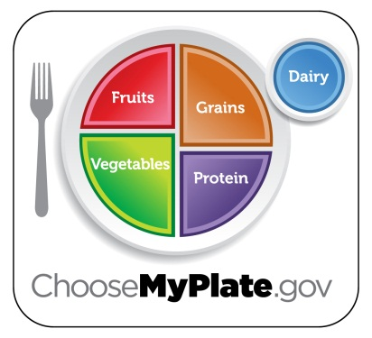
ChooseMyPlate Website Project
Nutrition & Wellness

- After receiving the results from your food record, how did your food intake compare to the recommended amounts? Provide a detailed explanation.

- How does your typical daily physical activity compare to the recommended amounts? Provide a detailed explanation.

- Was it easy or hard when planning a menu for 1 day that meets the recommended amounts for your personal daily food plan? Explain your answer.

- How can the information provided in this website be beneficial to you? How can you use it for your personal life? What information did you find most useful or helpful to you?

